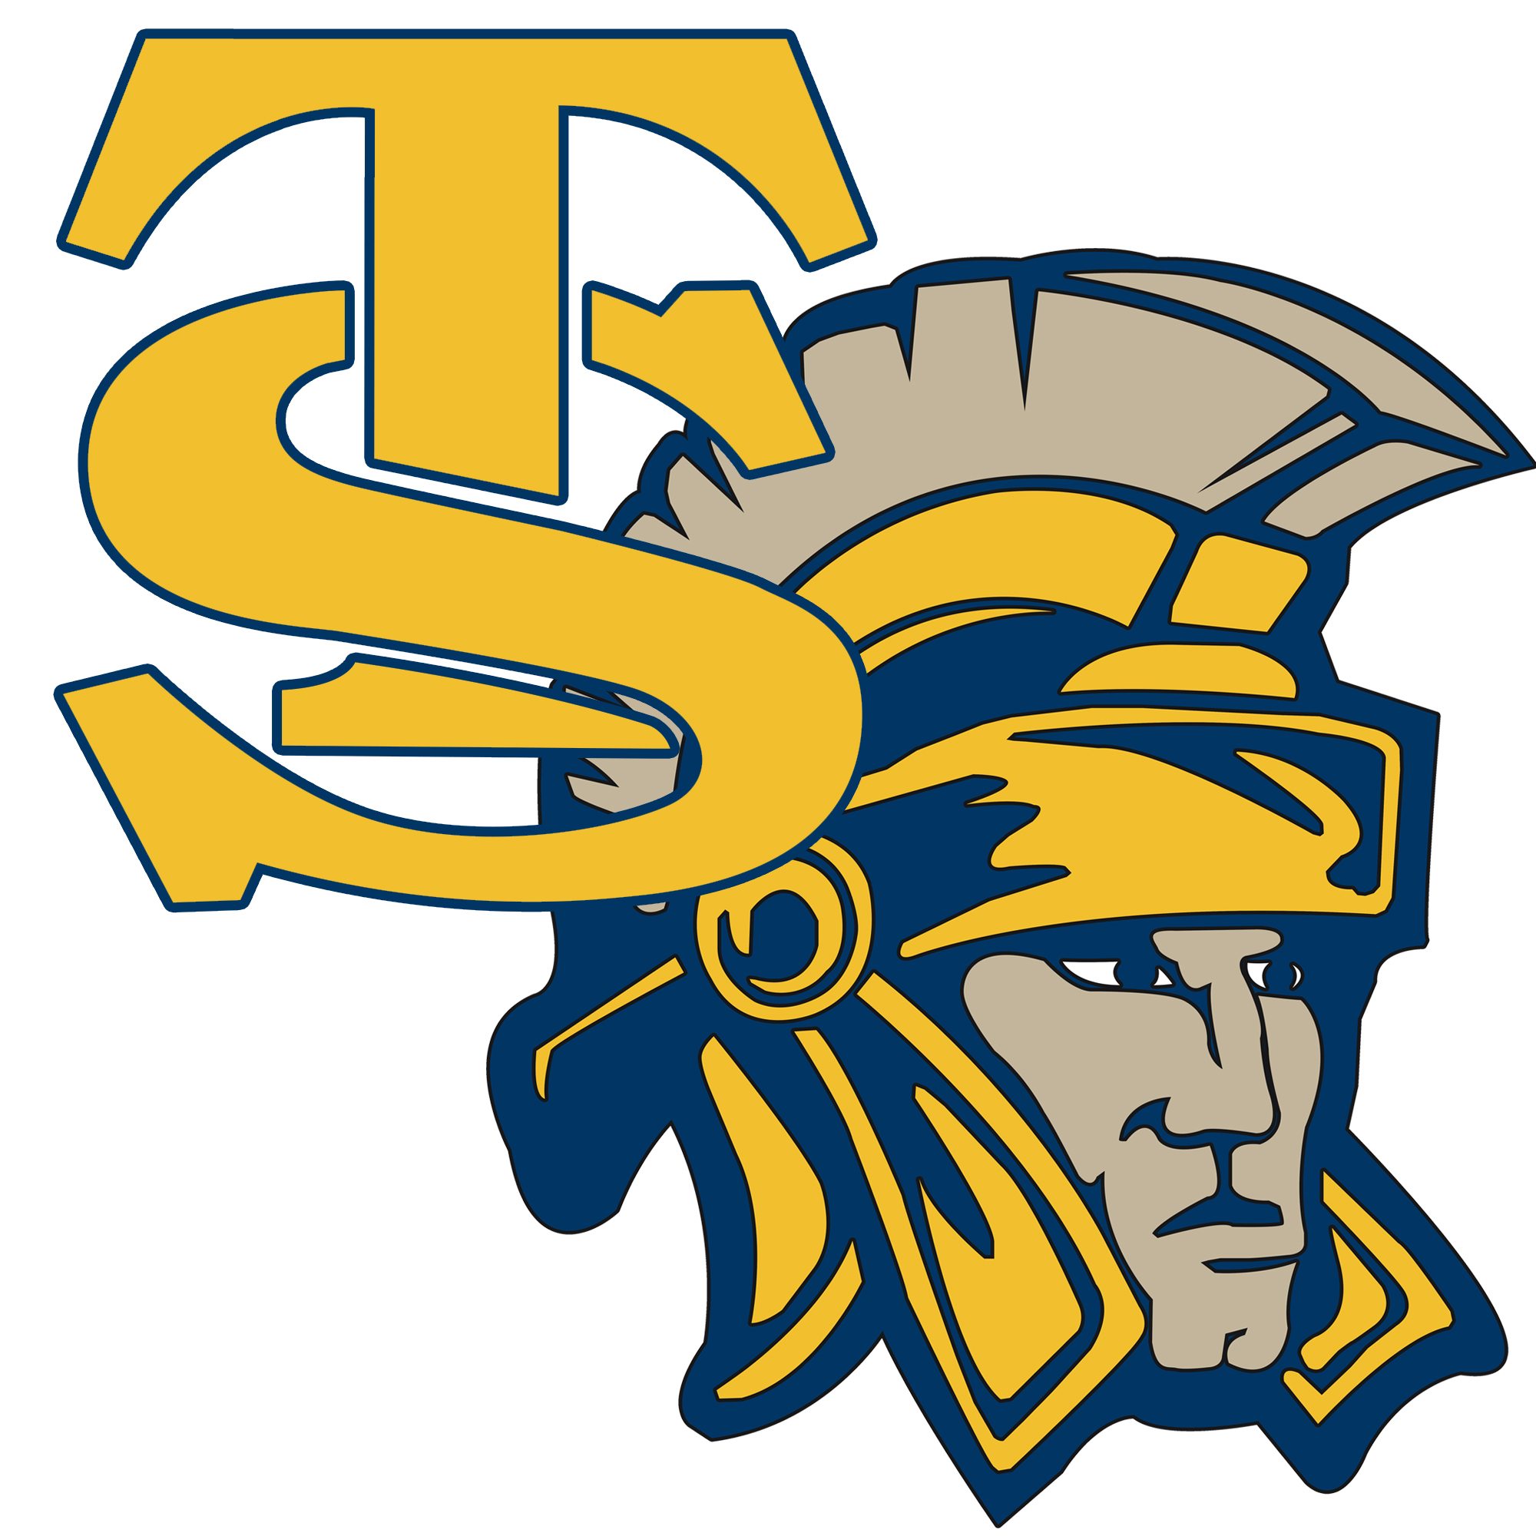

Trinidad State College
Athletic Handbook
2022-2023

Trinidad State College Athletics Mission Statement

Our mission is to develop student-athletes who will perform successfully in the classroom and compete at a championship level in their sport. We will provide quality programs designed to aid the student-athlete as they prepare themselves academically, physically, and socially to fulfill a meaningful role in society beyond their time at Trinidad State.

General Philosophy

It is the goal of the athletic department at Trinidad State College that every student-athlete who participates, or attempts to participate, is treated fairly and with the utmost respect by the coaching staff, faculty, and administration. It is also expected that every student-athlete put forth a positive image for Trojan athletics with his/her attitude and behavior. Each individual coach will outline the rights and responsibilities for student-athletes within that respective program, however, the goals for the Athletic Department remain focused toward each student-athlete having the memory of a great experience and possessing an associate degree when he/she leaves TSC.

Athletic Family

The athletic department personnel pride themselves on supporting one another and working very hard to be a cohesive unit. Functioning together, as a vital part of the overall educational experience at TSC. It is important that student-athletes from each sport understand that when one team or program succeeds, it will strengthen the whole group. It is our hope that all TSC athletes will work to earn the trust and respect of the programs in the other athletic disciplines.

Purpose of this Handbook

It is the goal of this department that each athlete’s experience at TSC will benefit him or her into the future. This handbook will outline the rules and expectations which will aid in that process. The student-athletes on campus will have dealings with many diverse groups, and the expectancies these groups have will fall into the three general areas of athletics, academics, and general social behavior and wellness.

Athletic Component

Student-Athlete Checklist

It is important that the student-athlete recognize it is their responsibility to be prepared when they come onto campus. These steps will aid in that preparation.

- Transcripts- Requests for official college, high school, and/or GED transcripts should be sent to the Registrar’s office upon completion of the application process.
- Athletic Forms – a list of forms including the FERPA release, the eligibility affidavit, and physical exam forms. These forms must be completed prior to the student-athlete beginning practice.
- Immunization Records - in order to live in the Residence Hall, you must have your immunization records sent to TSC.
- Financial Aid - To help defray other educational costs, the student-athlete is encouraged to apply for additional funding through the Financial Aid Office. (Remember to check your bill after census date and to set up payments)
- Student Athlete Bio form – complete this form each year

Insurance Coverage

In all athletic activity there is some risk of injury, which cannot be eliminated even by the most safety-conscious coaching staff. Knowing this to be true, the college seeks to assure that every student-athlete has health insurance that will cover the medical expenses associated with an athletic injury. The responsibility of providing such coverage rests with the student athlete, meaning all athletes at TSC must show proof of insurance prior to practicing or competing. If you cannot provide insurance a waiver must be signed. It is the responsibility of the student’s insurance company or the student athlete to provide initial coverage for the athlete.

Listed below are some guidelines regarding primary medical insurance:

- The primary insurance policy should have major medical coverage.
- Ensure that the primary insurance will cover athletic participation.
- Insurance coverage must be in effect whenever the student-athlete will be playing or participating in athletic activities. This includes pre-season, in-season, and off-season (if the sport has an off-season schedule).
- Ensure the student-athlete’s insurance coverage is effective in the Trinidad area, and will pay claims to our local doctors.
- The primary insurance deductible should not exceed $1,000.

Note: The student-athlete is responsible for the deductible or co-payments, as well as all other expenses not covered by their primary insurance policy and for what TSC’s secondary insurance will not pay.

Student-athletes will not be allowed to participate in TSC athletics without the verification of effective primary insurance or a signed waiver. Student-athletes who suffer an injury while not under primary insurance coverage will be responsible for the payment of all accrued bills up to the $2,500

TSC does provide a secondary athletic injury insurance policy with a $2,500 deductible. This coverage will provide:
- Coverage for athletic injuries only. It does not pay for non-athletic illnesses, or for injuries that do not occur during the scheduled practices or games.
- As an excess insurance, subject to the limitations in (a) above only after another insurance company has paid $2,500 toward that injury (to fulfill the deductible) and only for the cost that the primary insurance does not pay. The college cannot provide funds to meet the deductible or (b) The student athlete pays the initial $2500.
TSC also provides a catastrophic coverage that carries a $25,000 deductible and will pay benefits over a ten-year period up to 5 million dollars. This comes available when $25,000 of medical, dental and/or rehabilitation expenses are incurred within two years of the date of a covered accident.

Athletic Scholarships

Athletic scholarships at Trinidad State usually cover tuition and related student fees per semester. Cancellation of an athletic scholarship is permitted based only on the following circumstances which are laid out in Article VIII, Section 1.F of the NJCAA bylaws -

- If the student-athlete becomes ineligible for participation in athletics because of academic and/or disciplinary reasons; or
- For misconduct (unrelated to athletic ability) found by the person or body in charge of general discipline at the institution, after following the same procedures as in other disciplinary matters, to be serious enough to warrant permanent suspension or dismissal from the athletic program; or
- If the student-athlete voluntarily withdraws from a sport prior to the institution’s first competition in that sport; or
- Graduation

The athlete can be released from the scholarship upon the athlete’s request in order to look to transfer to another school, but the student will may become responsible to pay for the remaining percent of the semester.

Academics

General Degree Requirements:

It takes approximately 60-credit hours to graduate from Trinidad State College. Approximately 30-credit hours of core classes and 30-credit hours of approved electives. Depending upon course descriptions and how those hours are distributed will determine if the degree is an AS (Associate of Science), AA (Associate of Arts), AGS (Associate of General Studies) or AAS (Associate of Applied Science). Remedial work in mathematics, English and or reading will not be allowed to count toward the 60-hour requirement. Also, “D” grades will not count toward graduation. Refer to the TSC academic catalog for specific requirements for each degree program.

Basic Eligibility Requirements:

Student-athletes entering TSC for his/her freshman season must have earned a high school diploma or GED completion certificate, and be enrolled in at least 12 hours in order to be eligible to participate in an athletic program.

At the end of the first term of attendance, you must have completed 12 credit hours with a 1.75 grade point average (GPA) or higher. Best grades can be used for the computation of the GPA. (Esports requires a 2.0 GPA or higher at all times)

A second-year student-athlete must have completed 24 credit hours of course work with a minimum GPA of 2.0 and be enrolled in at least 12 hours in his/her third semester.

Transfer students are under the same guidelines as second year students academically if he/she were a full-time student the year before he/she transferred.

Remedial work in mathematics, English, and or reading will count toward a student athlete's eligibility.

The standards above reflect the minimum eligibility requirements set by the NJCAA. Keep in mind that your coach has the authority to require stricter standards for playing eligibility.

Attendance Policy:

Student-athletes are expected to attend class each and every time it meets unless his/her team is traveling to compete. Each coach will have a list of expected days the teams will miss because of competition. That list will be made known to the faculty, however it is still the student-athlete’s responsibility to inform each teacher of an upcoming athletic road trip or competition that will keep him/her out of class. Excused absences are limited to athletic trips, physical illness and family emergencies. Any other absences will be recorded as unexcused and will carry a graduated penalty. Ultimately, three or more unexcused absences could lead to suspension from competition. Habitual offenders will be dismissed from the athletic program at TSC.

Grade Checks:

Your coach will be checking D2L to monitor your academic progress. D2L will tell you and your coach where you are in the class in regard to absences and any missing work. If your “Grade Check” is negative the coach may take action by holding you out of practice or competition.

Student-Athlete Discipline Policy

Athletic participation at Trinidad State College is a privilege, and as a privilege there are responsibilities associated with that privilege. The conduct of our student-athletes should be one of absolute and total respect to the overall mission of Trinidad State College. Failure of any student-athlete in any program to live up to the expectations outlined in the athletic handbook code of conduct will lead to the consequences outlined in the Student-Athlete Discipline Policy.
This document outlines the potential consequences for a student-athlete’s behavior as it relates to violations of local, state or federal laws. In addition to this policy, student-athletes are subject to the rules and regulations of their individual team, of the TSC housing department and of all rules listed in the TSC Student Handbook. Team rules may be stricter than the policies outlined in this document.

The athletic director or other designated college authority may review and modify sanctions if circumstances of the violation warrant such action. The sanctions included below pertain to the entire time the student-athlete participates for TSC athletics and will carry over from year-to-year.

Criminal Violations of Local, State or Federal Laws

Suspension for Criminal Violations

If the Athletic Department has information that a student-athlete has been arrested or charged with a violation of local, state, or federal law involving violent crimes such as rape or assault, theft, drug possession or distribution or major alcohol infractions such as DUI or felony charges of any kind, the student-athlete shall be automatically suspended from athletic competition. The suspension will remain in effect until charges have been dropped or the issue has been otherwise resolved by the legal system.

- First Infraction. The student-athlete shall be indefinitely suspended from competition and may be suspended from practice.
- Second Infraction. The student-athlete shall be dismissed from the team.

Lessor Infractions

A student-athlete arrested or charged with infractions such as public intoxication, disorderly conduct, a minor in possession of drugs or alcohol. Also, students charged with infractions of school policy and discipline via the student services office, are subject the following sanctions.

- First Offense – A meeting with the coach outlining and documenting the offense combined with some type of physical exertion above the normal physical fitness required in practice, or if deemed necessary by the coach of that program a 1 to 3 game suspension during the primary sports season for that team.
- Second Offense – Suspension for 10%-15% of the games during the primary sports season for that team.
- Third Offense – A meeting with the Athletic Director and coach outlining and documenting offenses combined with removal from the team and a possible revocation of the athletic scholarship.

Suspension Guidelines

If suspended from the team, the student-athlete will not be able to compete in games, but will be allowed to use the facilities. The student-athlete may be suspended from practice. This ruling will be determined by the head coach.

Dismissal Guidelines

If dismissed from the team, the student-athlete will not compete in games and will not practice or strength train/condition with the team. There is a possibility that financial aid may be discontinued.

Due Process

Student-athletes at Trinidad State are guaranteed procedural due process in all cases in which they are accused of violating Athletic Department or College regulations:
a) In less serious cases involving a minor offense the appropriate coaching staff may take corrective action. An appeal by the student-athlete may be made to the Athletic Director.
b) In a more serious conduct situation, where suspension or dismissal is possible, the Head Coach and/or the Athletic Director along with the Trinidad State administration may determine the disciplinary action. An appeal of that decision may then be made to the Vice President of Student Services.
c) Student-athletes may also opt to follow the grievance procedures as outlined in Section VIII of the Student Handbook.
d) All attempts to render a fair and just decision to any offense will be made as quickly as possible.

Appeals Process

All appeals and responses are forwarded to the Athletic Director or designated official for initial review to determine if the appeal meets the limited grounds and is timely. The original finding(s) and sanction(s) will stand if the appeal is not timely or substantively eligible, and the decision is final.

If the appeal has standing, the documentation is reviewed. Because the original finding(s) and sanction(s) are presumed to have been decided reasonably and appropriately, the party appealing the decision must specifically cite the error(s) in the original determination on which the appeal is based. The only grounds for appeal are as follows:

1. A material procedural or substantive error occurred that significantly impacted the outcome of the hearing (e.g. substantiated bias, material deviation from established procedures); which must be explained in the written appeal; or

2. To consider new evidence, unavailable during the investigation or hearing that could substantially impact the original finding or sanction. A summary of this new evidence and its potential impact must be included in the written appeal, as well as the reasons the new evidence was not available during the original proceeding. Failure to participate in the initial process does not constitute as new information for the appeal process.

If the Athletic Director or designated official determines that a material procedural or substantive error occurred, it may return the complaint with instructions to reconvene, in order to cure the error.
In rare cases of bias, where the procedural or substantive error cannot be cured by the Athletic Director or designee, a new review may be held by a different designated official acting in the place of the Athletic Director or designee. The results of a reconvened hearing cannot be appealed. The results of a new hearing can be appealed once on (either or both of) the two applicable grounds for appeals.

For more information on the appeal hearing procedure, check out CCCS System President Procedure SP 4-30, https://www.cccs.edu/about-cccs/state-board/policies-procedures/ or contact the Vice President of Student Services at 719-846-5643.

Other Policies that affect the Student Athlete

Violations of College Regulations
Violations of the College Student Disciplinary Regulations are listed in the student handbook. They fall under the jurisdiction of the Vice President of Student Services office and will be handled accordingly.

Violations of Team Rules
Each head coach will develop and enforce his or her own set of team rules to establish standards for team conduct. These rules may be more restrictive than athletic department or college rules. Head coaches have the authority to suspend or dismiss student-athletes if violations of team rules warrant such a decision. Appeals of dismissals by the head coach because of team rules violations are to be resolved by the Director of Athletics or a designated representative. Team policies will be on file with the Athletic Director.

Alcohol and Marijuana Policy
The Athletic Department is concerned with the health and safety of the student-athletes who participate in its programs. Unlawful possession, use or distribution of alcohol or marijuana by student-athletes is prohibited. The Drug and Alcohol Free Campus Federal Law restricts any alcohol or drugs on campus or associated with a college activity.

A student who has been reported for a first violation of this policy will be subject to the following sanctions:

- First Violation: A two game suspension combined with some type of physical exertion above the normal physical fitness required in practice
- Second Violation: Suspension for 10%-15% of the games during the primary sports season for that team. Possibility of drug/alcohol counseling to be determined by BIT team
- Third Violation: Possible dismissal from the team, suspension from team activities, and possible forfeiture of scholarship.

Drug Testing Program

Trinidad State athletes are required to participate in the probable cause (reasonable suspicion) drug-testing program outlined and discussed early each year. Failure to sign consent to test form under probable cause guidelines, or failure to test when requested to, will result in dismissal from his or her perspective team and immediate loss of scholarship.

Reasonable Suspicion Selection for Testing

- The circumstances or events giving rise to individualized reasonable suspicion drug testing shall be recorded in writing by the head coach. Testing without prior notice is permissible.
- “Reasonable suspicion” shall not mean a mere “hunch” or “intuition.” It shall be based upon a specific event or occurrence, which leads to the belief based on reasonable circumstances that a student-athlete has used a banned substance.
- Such belief may be engendered by direct observation, a physical or mental deficiency, medically indicated symptomology of banned substance use, suspicious conduct, or unexplained absence.
- Such belief may also be engendered by information supplied by reliable third parties corroborated by objective facts.
- Such belief may also be engendered by common-sense conclusions about observed or reliably described human behavior upon which practical people ordinarily rely.

Residence Hall Expectations

Student-athletes make up a rather large percentage of the student population in the Residence Halls located on the TSC campus. Therefore, it is vital to the success of our athletic program that student-athletes set a positive example for non-athletic students to respect and hopefully emulate. Community living is a difficult adjustment for anyone at any age. Below is a list that will not only help the adjustment but also keep you, as a TSC student-athlete informed of the expected behavior in the dormitories.

- Keep your rooms locked and dead bolted when you are not in it.
- Protect all belongings inside the room.
- If you suspect that your roommate is not trustworthy go to the proper authorities immediately. (Dorm directors and coaches)
- Never have illegal drugs or alcohol in your dormitories or in your rooms. (Even if you are of age)
- Abide by team-imposed curfews and by all residence hall visitation limits.
- Never allow underage students in the dormitories or in your room, even during visiting hours.
- Treat Residence Hall personnel as if they were members of your own family. These people are college employees and the coaching staff will be in constant communication with them about the behavior of student athletes.

Note: The residence hall handbook is the main authority for all student-athletes while living in the residence halls. Disciplinary actions will be dealt with as outlined in that handbook by Residence Hall Directors in conjunction with our College Administration. Any infractions that may fall outside of the realm of the director will be dealt with by local law enforcement agencies. Athletic disciplinary action will occur separately, in accordance to the consequence by rules outlined in this handbook.

Cafeteria Expectations

Meals in the cafeteria are provided by the Sodexo Food Corporation. It is important that the athlete takes advantage of these services by eating every meal possible. Since this is a public eating-place, it is expected that the student-athlete exhibit exemplary behavior while dining in the cafeteria. Below is a list of reminders, which if followed, will bring athletics much needed respect and admiration from the general student, faculty and staff population at TSC.

- Keep noise levels limited to normal dining conversations.
- Abstain from the use of profanity and crude joking.
- Say please and thank you to the cafeteria staff on a regular basis.
- Bus trays and clear all tables as you leave
- Do not take silverware, cups or any other eating utensils that belong to Sodexo out of the dining area for any reason.
- Do not cut in line.
- If you have complaints about the food and or procedures, please channel them through the proper authorities in the Vice President or Student Service’s office.

Social Media Policy

Social network sites such as Facebook, Twitter, Snapchat, Instagram, and any other new platforms facilitate students communicating with family and friends. Participation in such online communities has both positive appeal and potentially negative consequences. It is important that student-athletes be aware of these consequences and exercise appropriate caution if they choose to participate.

Student-athletes are not restricted from using online social network sites and digital platforms. However, violations of college policy (e.g., harassing language, alcohol or drug policy violations, etc.) or evidence of such violations in the content of online social networks or digital platforms are subject to investigation and sanctions under the Student Code of Conduct, Student-Athlete Code of Conduct, and other policies.

Social Media Guidelines for Student-Athletes

The following guidelines are intended to provide the framework for student-athletes to conduct themselves safely and responsibly in an online environment.

- Be careful with how much and what kind of identifying information you post on on-line social network sites. Virtually anyone can access your page. It is unwise to make available information such as full date of birth, social security number, address, residence hall room number, phone number, cell phone numbers, class schedules, bank account information, or details about your daily routine.
- Any text or photo placed online is completely out of your control the moment it is placed online.
- You should think about any information you post on Facebook or similar directories potentially providing an image of you to a prospective coach/employer. The information posted is considered public information. Protect yourself by maintaining a self-image that you can be proud of years from now.
- Think before you post! If you are ever in doubt of the appropriateness of something you put on social media, think about whether it positively reflects your own ethics and values. Remember, it is best to always present a positive image and try not to do anything that would embarrass you, your family, your team or the institution.

NJCAA Code of Ethics:

It is a requirement from the National Junior College Athletic Association that each student-athlete who participates reads a copy of the NJCAA code of ethics which governs its athletic events. In signing this form, you as a Trinidad State College student-athlete are acknowledging that you understand the contents of this code and will adhere to them as well as the expectations outlined in this student handbook.

Trinidad State College Athletic Staff

Dr. Rhonda Epper - President
Mike Salbato - Athletic Director
Kyle Masterson – Assistant Athletic Director
Christy Holden - Registrar

Head Coaches

Stephen Swazo - Women’s Softball – 17th year
Michael Folda - Men’s Basketball – 13th year (17th year at TSC)
Lauren Masterson - Men’s and Women’s Cross Country – 7th year
Peter Freeman - Women’s Soccer – 6th year, Men’s Soccer – 4th year
Destiny Bragman - Women’s Basketball – 4th year (7th year at TSC)
Karli Bustos - Women’s Volleyball/Beach Volleyball – 3rd year
Kyle Masterson - Men’s and Women’s Track and Field – 1st year (6th year at TSC)
Jason Veyna - Baseball – 1st year

Assistant Coaches

Baseball –
Men’s Basketball – Andrew Riley,
Women’s Basketball – Jenny Hugins, Justin Bustos
Cross Country – Kyle Masterson
Women’s and Men’s Soccer – Tim Busen
Softball –Tori Martinez
Volleyball – Damon Salazar, Tori LeBay

Important Campus Numbers

Security 719-846-4441 (police dispatch)
Student Life 719-846-5517
Maintenance 719-846-5618
Housing 719-846-5497
Dining Services 719-846-5629
Bookstore 719-846-5610
Financial Aid 719-846-5553
Business Office 719-846-5546
IT – Computer Services 719-846-5663
Tutoring 719-846-5664
Title IX Coordinator 719-846-5534

Non-Emergency Community Contacts

Trinidad Police Station 719-846-4441
Las Animas County Sheriff 719-846-2211
Ambulance Service 719-846-7360
Fire Department 719-846-2432
Hospital 719-846-9213
Mt. Carmel Medical Center 719-845-4880

Student Records and Transcripts (FERPA)

The Family Educational Rights and Privacy Act of 1974 (FERPA) sets the requirements pertaining to the privacy of student records. The Trinidad State College Athletic Department will follow the guidelines related to the storage and release of records as outlined in Section IX of the Student Handbook.

Student Athlete Contract

As a member of a Trinidad State College athletic team, I hereby agree to abide by the following rules and guidelines:

- I will conduct myself in a manner befitting Trinidad State College and Trojan Athletics on the field/court and off the field/court
- I will uphold my status as a student first and fulfill the academic requirements set forth for me by the NJCAA as well as the Trinidad State coaching staff and administration
- I will refrain from the use of any illegal substances.
- I will perform any tasks set forth by the coaching staff to the best of my ability
- I will accept whatever role the coaching staff outlines for me and do my best to excel in that role
- I will exhaust all means to resolve all complaints or issues (personal, academic, or athletic) that involve me, the team, or coaching staff personally with the head coach
- I will abide by team policies in regards to appearance, behavior, and extracurricular activities
- I will do my best to work within my coach’s team philosophy and take pride in being a member of a Trinidad State athletic team

I understand that failure to adhere to any of the above could result in the forfeiture of my ability to participate on a Trinidad State athletic team and that the coaching staff and/or Athletic Director will make all determinations of compliance with the above rules and guidelines.

Name: _______________________________________________ Date: ______________________

Signature: ___________________________________________________ Sport: ____________________

Additional Agreement for Players on Athletic Scholarship

I understand that my scholarship is awarded on a semester-by-semester basis, and that I may forfeit my scholarship at any time by:

- Failure to pass 12 hours in any given fall or spring semester
- Failure to maintain a 2.00 GPA
- Failure to adhere to all of the above rules and guidelines
- Acting in a manner unbecoming of a member of a TSC athletic team
- Becoming ineligible according to NJCAA regulations
- Being dismissed from the team for any reason

Signature: _________________________________________________ Date: __________________________

